**Experiment No: 04**

**Experiment Name:** To configure dynamic IP routing through DHCP(Dynamic Host Configuration Protocol)  
**Procedure :**

Step 1: Start and Open Cisko Packet tracer.

Step 2: Design Layout with End devices and End Networks.

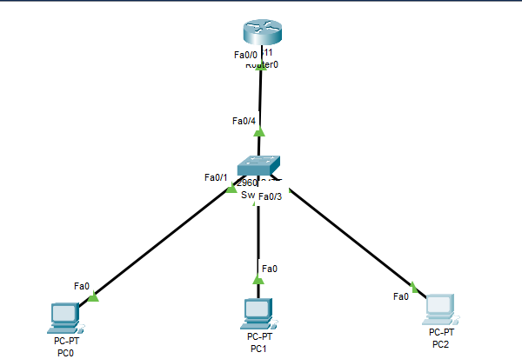

**Fig – DHCP Devices Layout**

Step 3: Configure Router0

Click Router0 then CLI then now write command in configuration dialog.

Router>en

Router#configure terminal

Enter configuration commands, one per line. End with CNTL/Z.

Router(config)#dhcp pool netA

^

% Invalid input detected at '^' marker.

Router(config)#ip dhcp pool netA

Router(dhcp-config)#network 192.168.31.0 255.255.255.0

Router(dhcp-config)#default-route 192.168.31.1

Router(dhcp-config)#exit

Router(config)#interface fastethernet 0/0

Router(config-if)#ip address 192.168.31.1 255.255.255.0

Router(config-if)#exit

Router(config)#exit

Router#wr

Building configuration...

[OK]

Step 4: Open PC0 IP-Configuration and then click DHCP. It automatically takes IP address from DHCP Server.

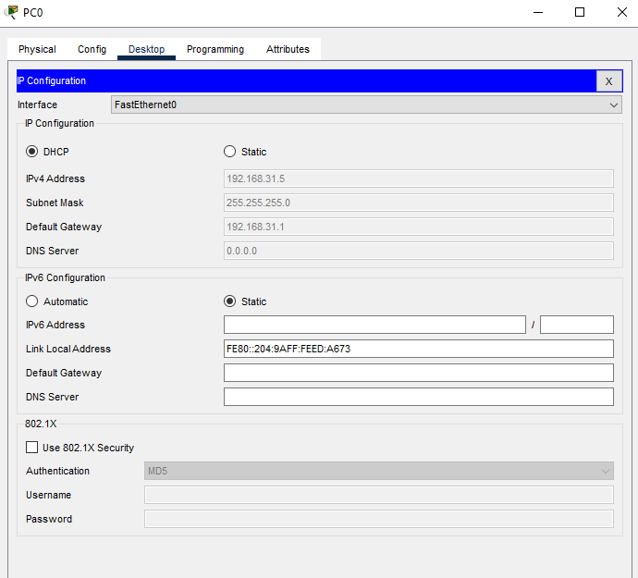The other PC’s also take IP Address dynamically from DHCP Server

Step 5: Open Command Prompt of PC1 and sent ping to PC0

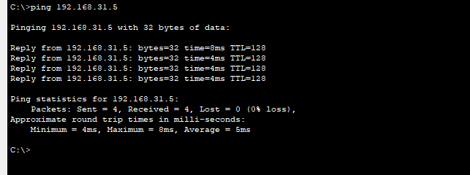`

**Experiment No:** 05

**Experiment Name:** Configure Enhanced Interior Gateway Routing Protocol (EIGRP)

Step 1: Start and Open Cisko Packet Tracer.

Step 2: Design with End devices and End Networks.

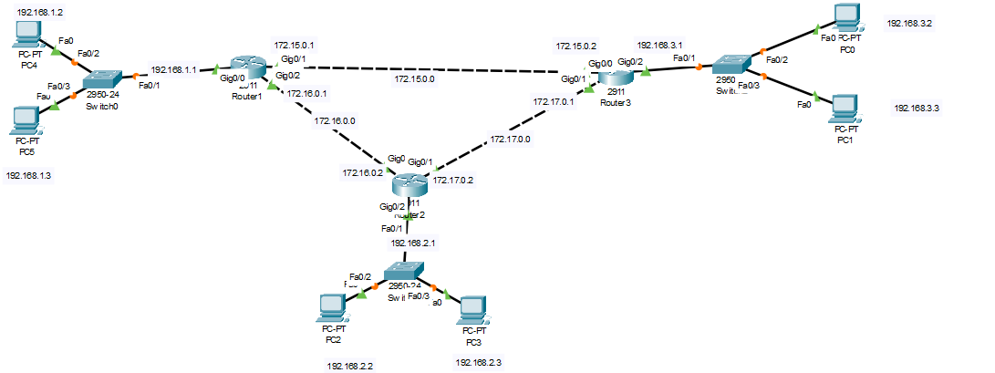

**Fig - Layout** **of EIGRP**

Step 3: Configure all End Devices. Connect all devices with end network device i.e. router as well as switch.

Here is two simple end devices layout/configuration,

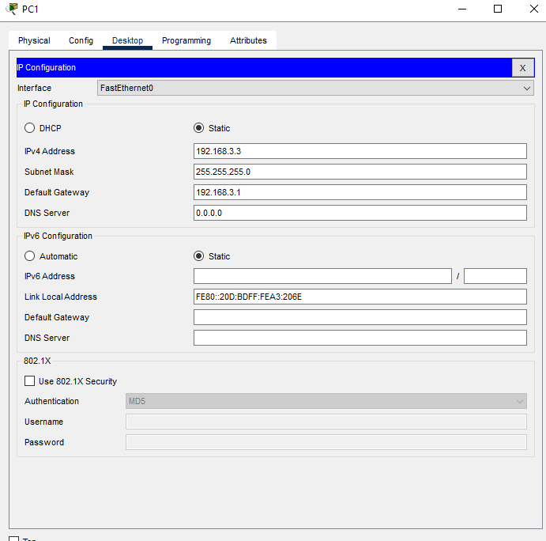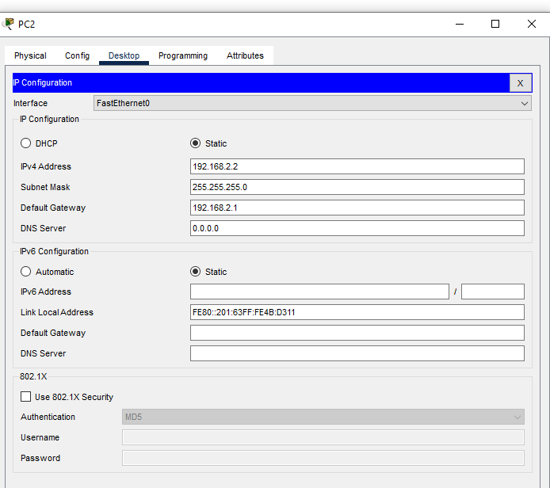

**Fig – Device Configuration**

Step 4: Configure Router1() using command prompt.

Router>en

Router#configure terminal

Enter configuration commands, one per line. End with CNTL/Z.

Router(config)#inihostname PUST

PUST(config)#exit

PUST#

%SYS-5-CONFIG_I: Configured from console by console

PUST#cocinter ter Gig0/1

^

% Invalid input detected at '^' marker.

PUST#interface terminal Gig0/1

^

% Invalid input detected at '^' marker.

PUST#configure terminal

Enter configuration commands, one per line. End with CNTL/Z.

PUST(config)#inter ter gig0/1

^

% Invalid input detected at '^' marker.

PUST(config)#interface terminal Gig 0/1

^

% Invalid input detected at '^' marker.

PUST(config)#interface Gig0/1

PUST(config-if)#ip address 172.15.0.1 255.255.0.0

PUST(config-if)#no shutdown

PUST(config-if)#

%LINK-5-CHANGED: Interface GigabitEthernet0/1, changed state to up

PUST(config-if)#exit

PUST(config)#inter Gig 0/2

PUST(config-if)#ip address 172.16.0.1 255.255.0.0

PUST(config-if)#no shutdown

PUST(config-if)#

%LINK-5-CHANGED: Interface GigabitEthernet0/2, changed state to up

e

PUST(config-if)#exit

PUST(config)#int Gig0/0

PUST(config-if)#ip address 192.168.1.1 255.255.255.0

PUST(config-if)#no shutdown

PUST(config-if)#

%LINK-5-CHANGED: Interface GigabitEthernet0/0, changed state to up

%LINEPROTO-5-UPDOWN: Line protocol on Interface GigabitEthernet0/0, changed state to up

exe

PUST(config-if)#exit

PUST(config)#wr

**EIGRP Code Part:**

PUST#configure terminal

Enter configuration commands, one per line. End with CNTL/Z.

PUST(config)#EIErouter eigrp 20

PUST(config-router)#network 192.168.1.0

PUST(config-router)#network 172.15.0.0

PUST(config-router)#network 172.16.0.0

PUST(config-router)#exit

PUST(config)#exit

PUST#

Step 5: Similarly, Configure Router2() and Router3().

Here let’s see Router3() Configuration,

Router>en

Router#configure terminal

Enter configuration commands, one per line. End with CNTL/Z.

Router(config)#hostname SUST

SUST(config)#inter gig 0/0

SUST(config-if)#ip address 172.15.0.2 255.255.0.0

SUST(config-if)#no shutdown

SUST(config-if)#

%LINK-5-CHANGED: Interface GigabitEthernet0/0, changed state to up

%LINEPROTO-5-UPDOWN: Line protocol on Interface GigabitEthernet0/0, changed state to up

SUST(config-if)#exit

SUST(config)#inter gig 0/1

SUST(config-if)#172.17.0.1 255.255.0.0

^

% Invalid input detected at '^' marker.

SUST(config-if)#ip address

SUST#

%SYS-5-CONFIG_I: Configured from console by console

SUST#ip address 172.17.0.1 255.255.0.0

^

% Invalid input detected at '^' marker.

SUST#inter gig

^

% Invalid input detected at '^' marker.

SUST#configure terminal

Enter configuration commands, one per line. End with CNTL/Z.

SUST(config)#interface gig0/1

SUST(config-if)#ip address 172.17.0.1 255.255.0.0

SUST(config-if)#no shutdown

SUST(config-if)#

%LINK-5-CHANGED: Interface GigabitEthernet0/1, changed state to up

%LINEPROTO-5-UPDOWN: Line protocol on Interface GigabitEthernet0/1, changed state to up

SUST(config-if)#exit

SUST(config)#inter gig0/2

SUST(config-if)#ip address 192.168.3.1 255.255.255.0

SUST(config-if)#no shutdown

SUST(config-if)#

%LINK-5-CHANGED: Interface GigabitEthernet0/2, changed state to up

%LINEPROTO-5-UPDOWN: Line protocol on Interface GigabitEthernet0/2, changed state to up

**EIGRP Code Part:**

SUST(config-if)#exit

SUST(config)#router eigrp 20

SUST(config-router)#network 192.168.3.0

SUST(config-router)#network 172.15.0.0

SUST(config-router)#

%DUAL-5-NBRCHANGE: IP-EIGRP 20: Neighbor 172.15.0.1 (GigabitEthernet0/0) is up: new adjacency

SUST(config-router)#network 172.15.0.0

SUST(config-router)#network 172.17.0.0

SUST(config-router)#

%DUAL-5-NBRCHANGE: IP-EIGRP 20: Neighbor 172.17.0.2 (GigabitEthernet0/1) is up: new adjacency

SUST(config-router)#network 172.17.0.0 255.255.0.0

SUST(config-router)#exit

SUST(config)#exit

SUST#

%SYS-5-CONFIG_I: Configured from console by console

SUST#wr

Building configuration...

[OK]

Step 6: Open Command Prompt PC5 and send ping to PC0

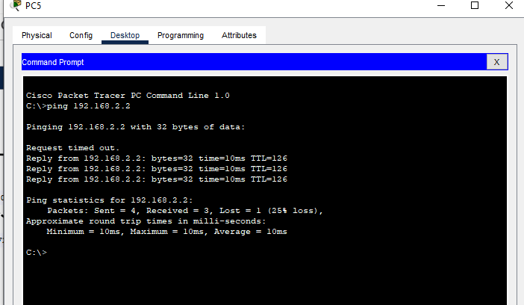

**Fig – Output of EIGRP**